CSCI 5408

DATA MANAGEMENT AND  
WAREHOUSING

ASSIGNMENT - 2

Banner ID: B00948977

Git Assignment Link : <https://git.cs.dal.ca/sukumaran/csci5408_f23_b00948977_balaji_sukumaran/-/tree/main/Assignment2/Reuters>

|  |
| --- |
| **Table of contents** |

|  |  |
| --- | --- |
| **Problem Statement 1A:** Flowchart of Problem 1A……………………………….………………………………………………. | **1** |
| **Problem Statement 1A:** Test Cases and Evidence of Testing using screenshots…….....………………………………….... | **4** |
| **Problem Statement 1B:** Explanation of Problem 1B………….………………….………………………………………………. | **11** |
| **Problem Statement 1B:** Test Cases and Evidence of Testing using screenshots…….....………………………………….... | **12** |
| **Problem Statement 2:** Test Cases and Evidence of Testing using screenshots………………………………………………. | **18** |
|  |  |

**Problem Statement 1A: Flowchart of 1A**

Following is the flowchart and Algorithm for the Reuters Data cleaning/transformation/storing in a MongoDB database.

**Algorithm:**

Step 1: File operation to read the news input files into a string variable rawNewsData (reut2-009.sgm and reut2-014.sgm)

Step 2: Clean the rawNewsData

- remove the replace the special characters of html escaping characters

- remove tagging symbols < >

Step 3: create news object by going to the text each between <REUTERS> and </REUTERS>

3.1. extract the data between each <TITLE> and </TITLE> create a title string

3.2. extract the data between each <BODY> and </BODY> create a body string

3.3. using the title and body create a news object.

Step 4: Store the list of created news objects as JSON to in a document-based database [1] (mongoDB).

**Flowchart:**

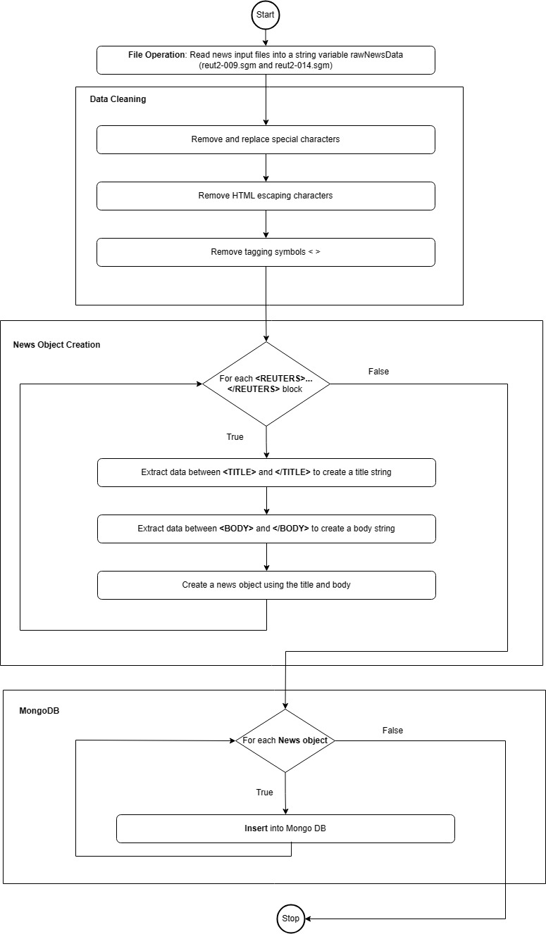

Figure 1: Flow chart for Reuters data extract/cleaning/Transformation

To insert the data to the MongoDB database. I got the collection created within my mongoDB account and appended each news object to the “Reuters” Document [2].

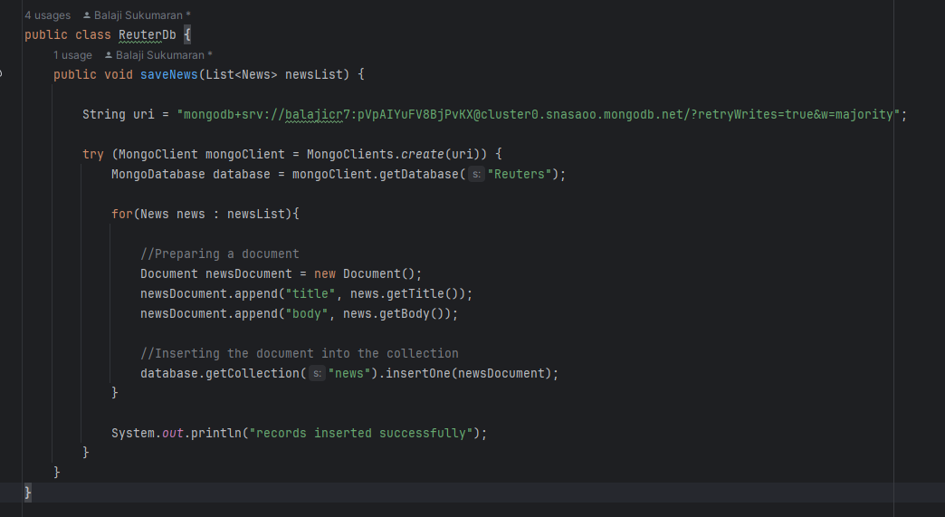

**Problem Statement 1A: Test Cases and Evidence of Testing using screenshots.**

Created a MongoDB free-tier account.

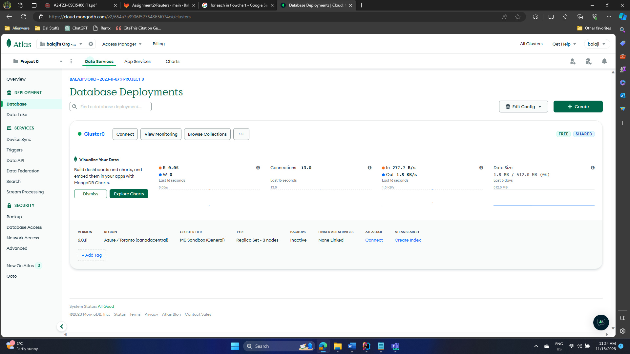

Figure 2: MongoDB account

Executing the program for extracting/cleaning/transforming the Reuters news data.

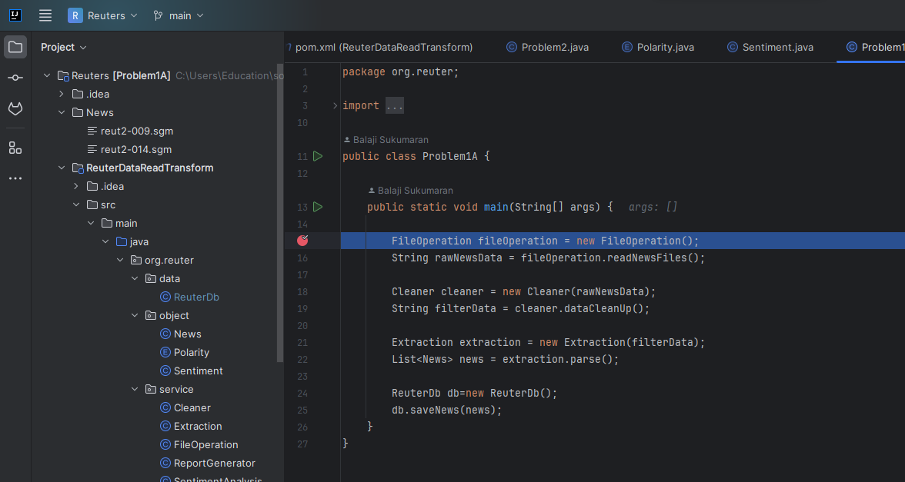

Figure 3: main program

File operation:

Two news files are there in the scope of the program.

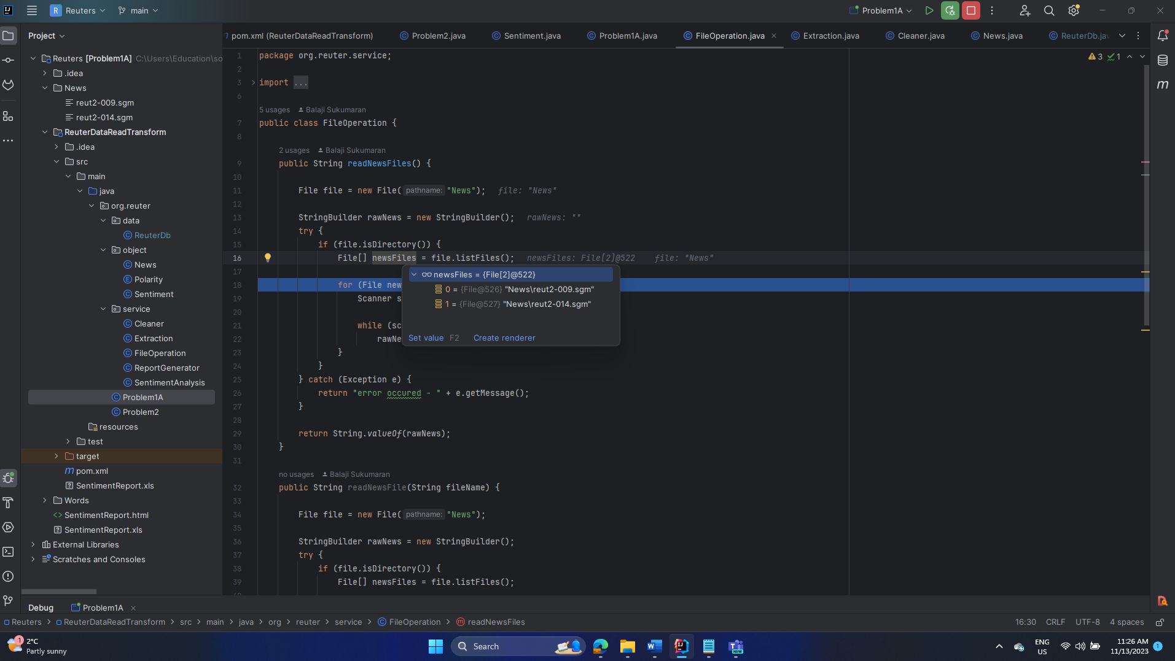

Figure 4: files in scope

RawNews variable contains both the news files (reut2-009.sgm and reut2-014.sgm) contents.

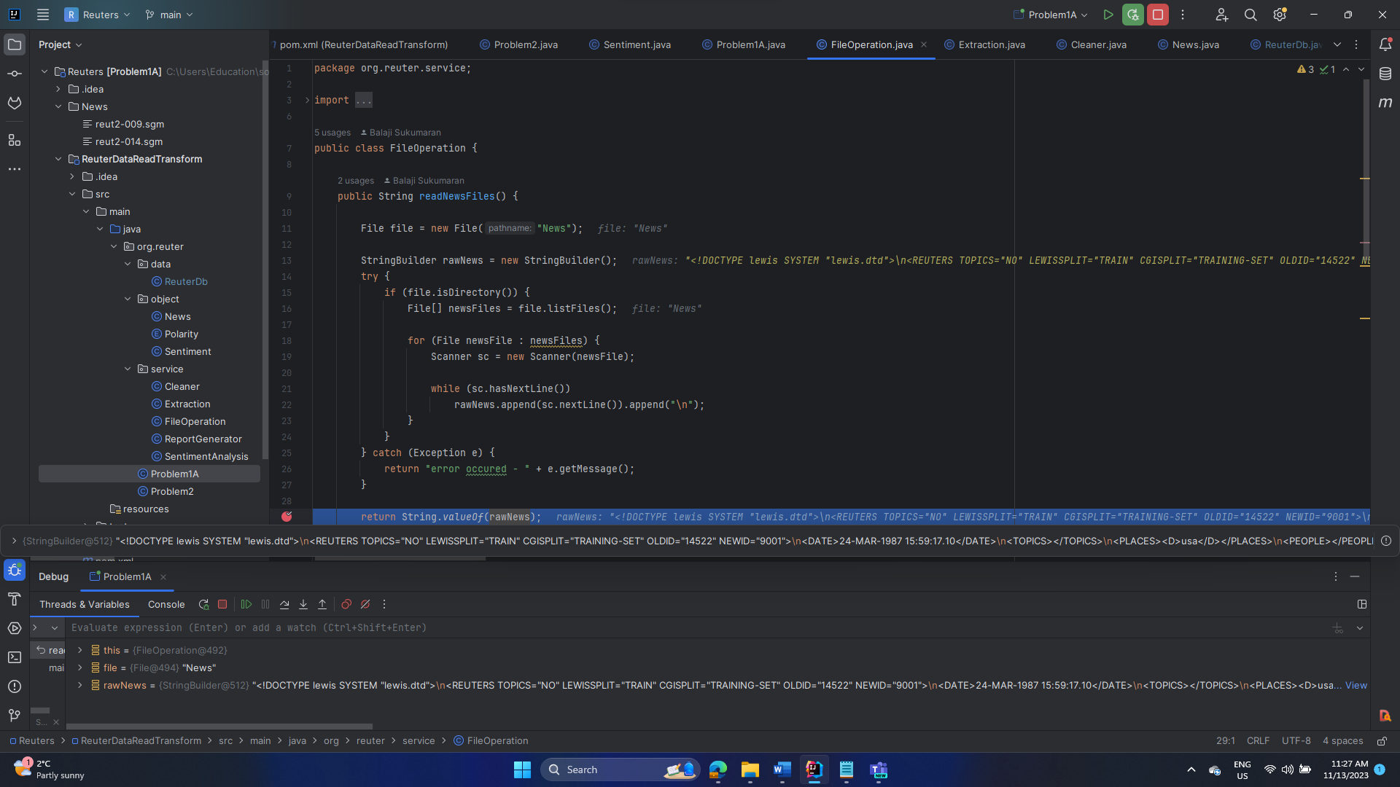

Figure 5: Contents of rawnews variable

Cleaning: Clean the raw news data from html escape characters

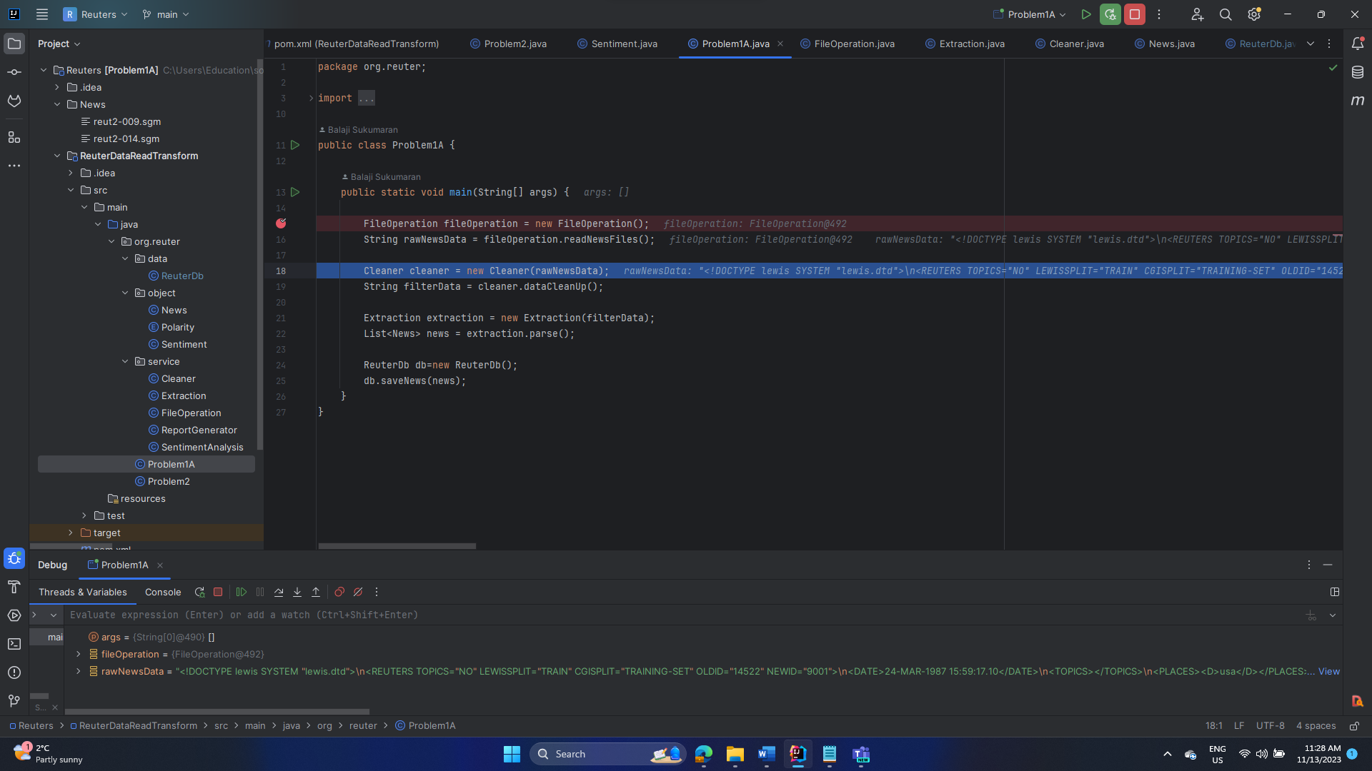

Figure 6: main method

Title is cleaned from all the html escape characters, Note: < > symbols will be cleaned before inserting into the mongoDB

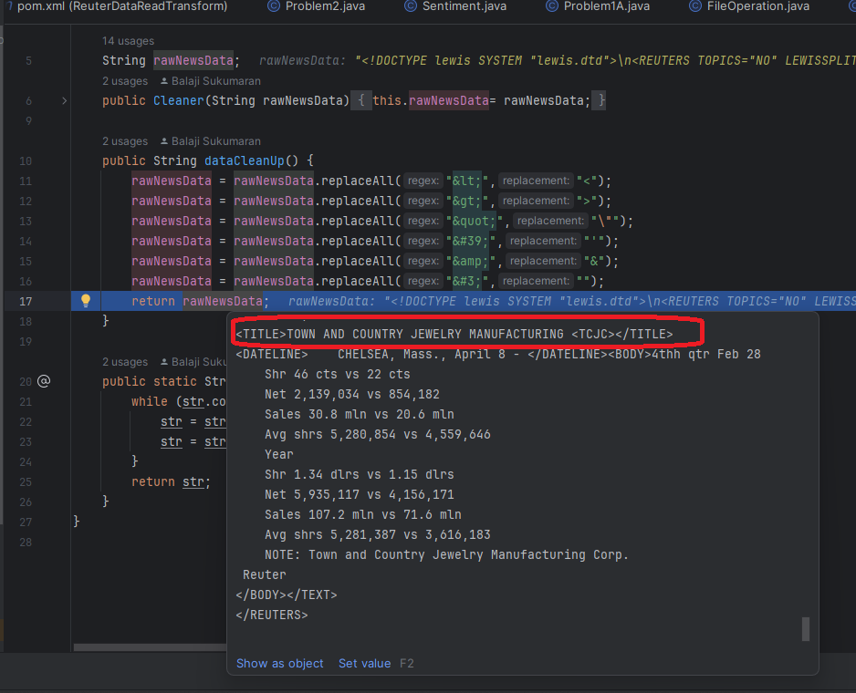

Figure 7: cleaned news title

Extraction: Creating news objects

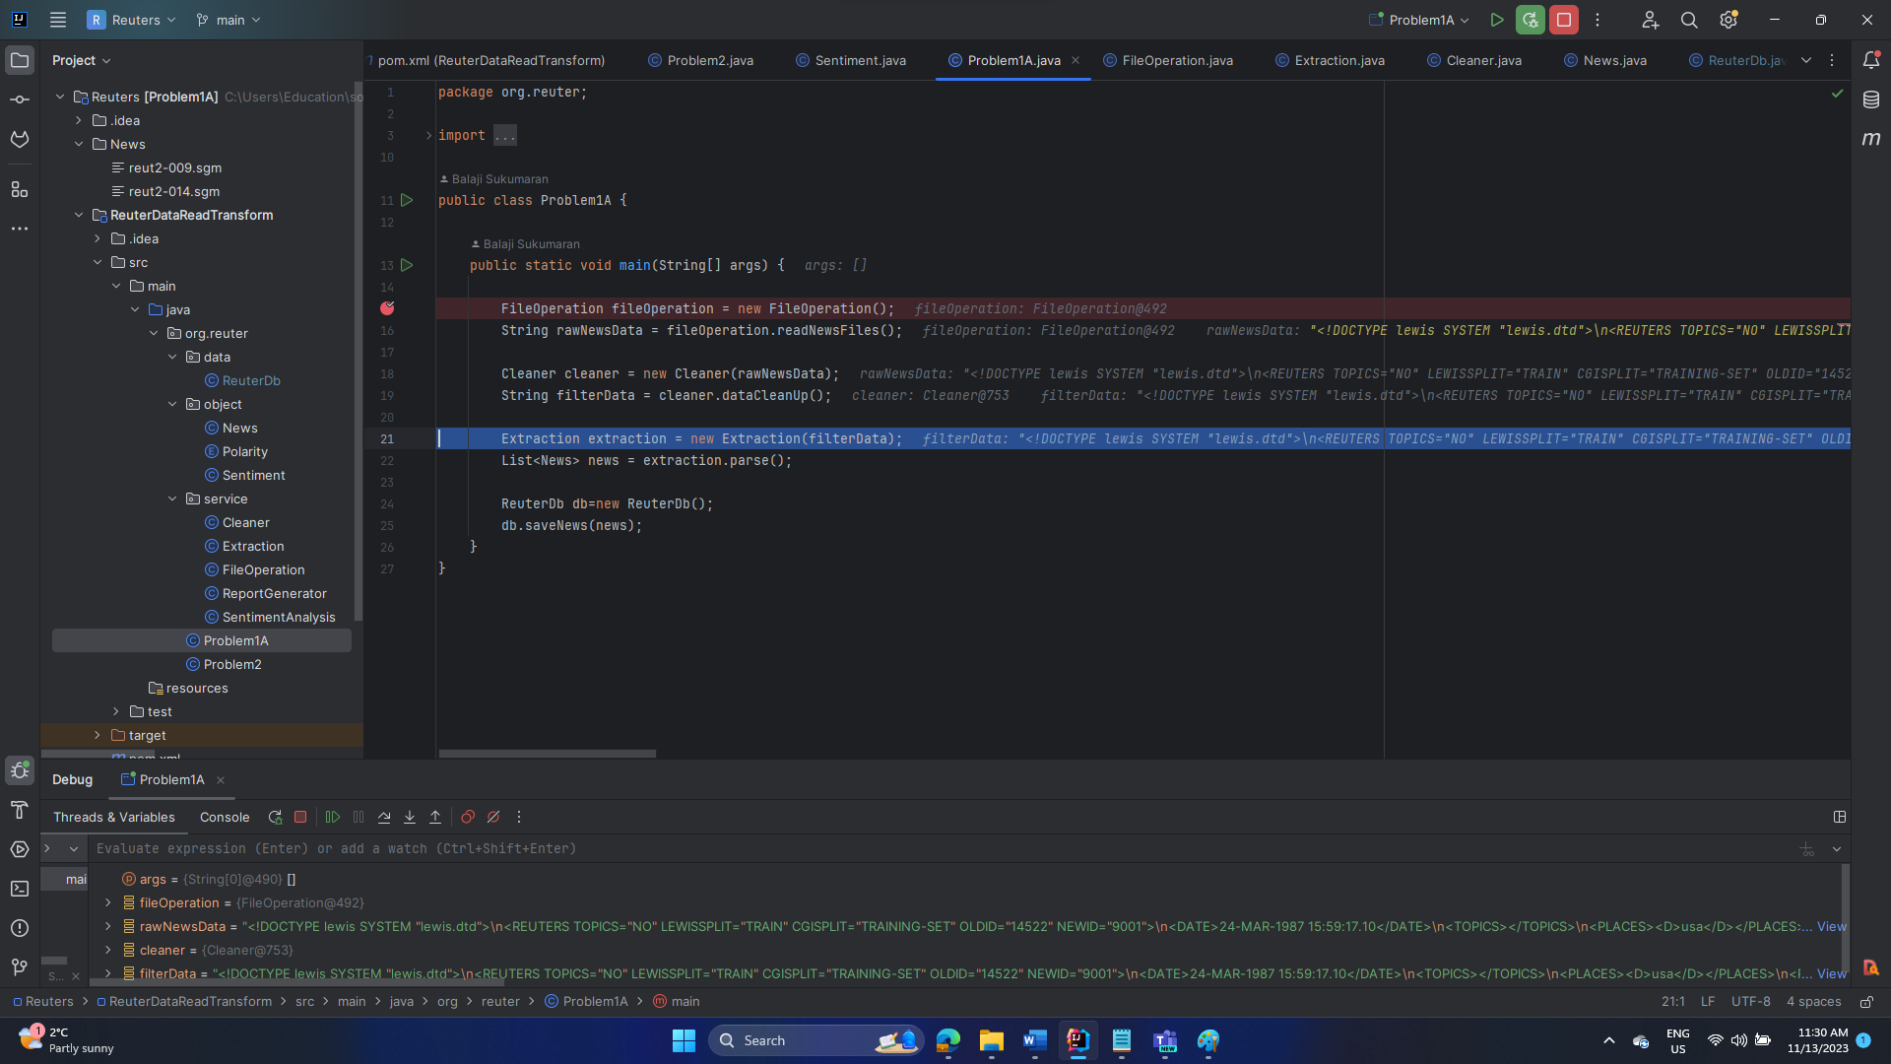

Figure 8: main method

Extract the contents between Reuters tags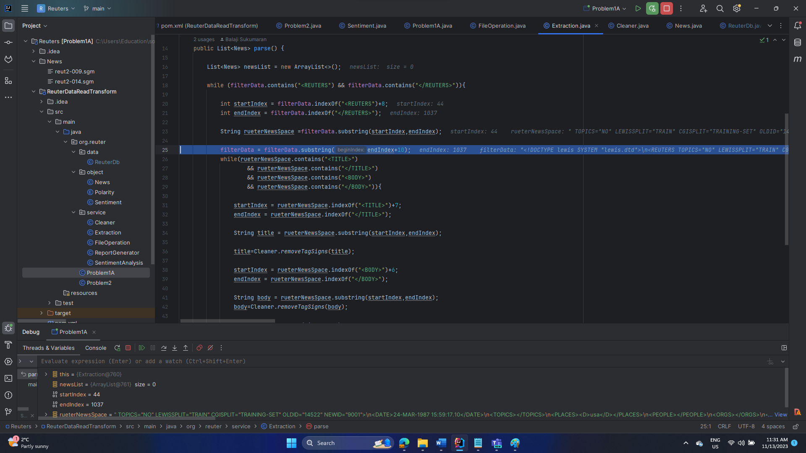

Figure 9: Extract the contents between Reuters tag

Extract the title within the Reuter context text. And remove the unwanted < and > symbols.

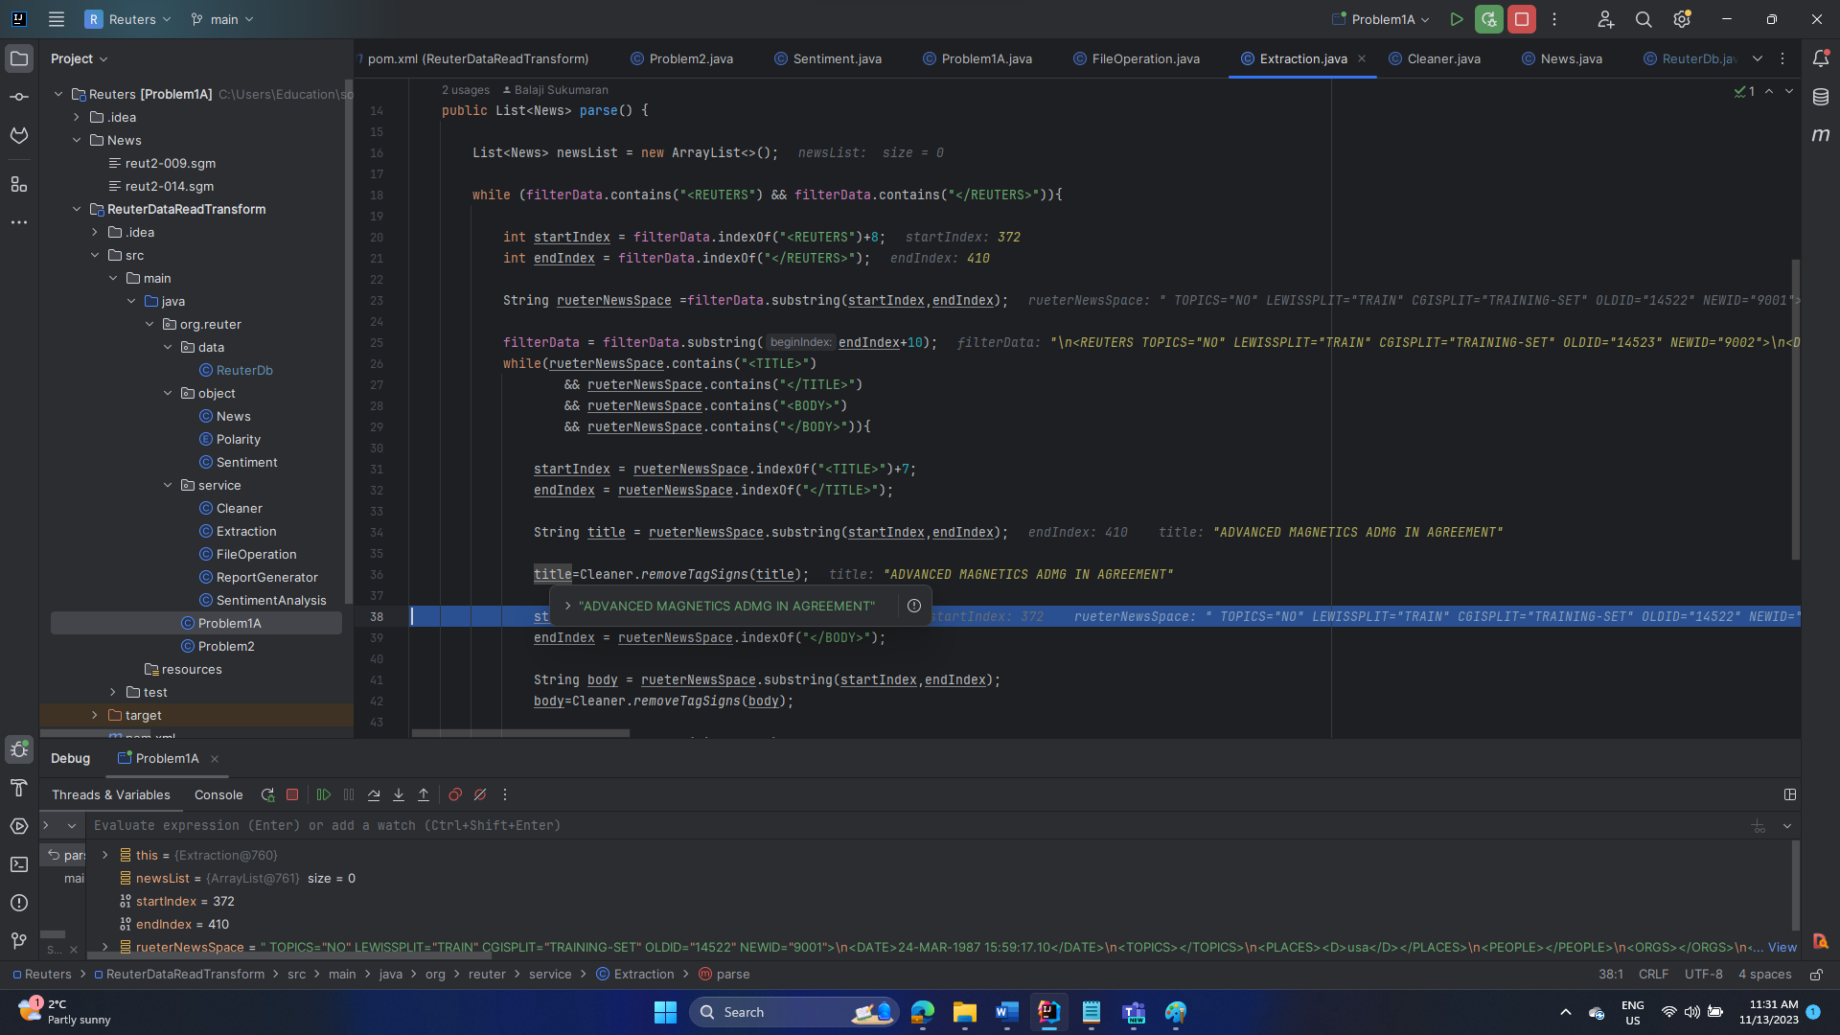

Figure 10: create Reuter news title

Extract the body within the Reuter context text. And remove the unwanted < and > symbols.

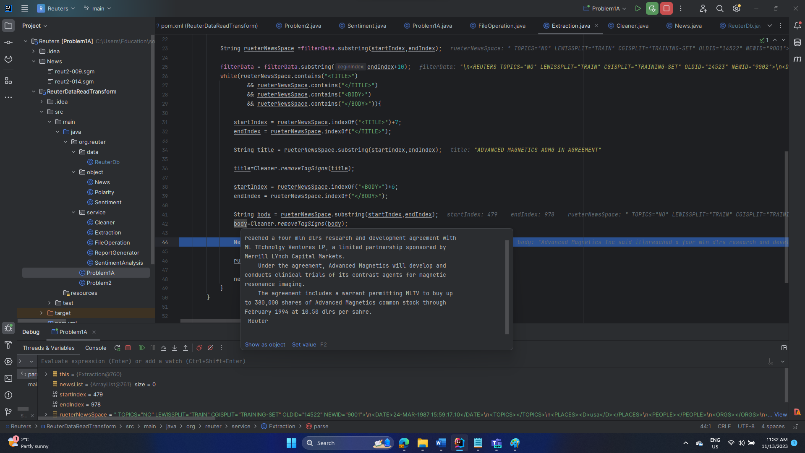

Figure 11: create Reuter news body

Create a news object with title and body and insert into the newsList.

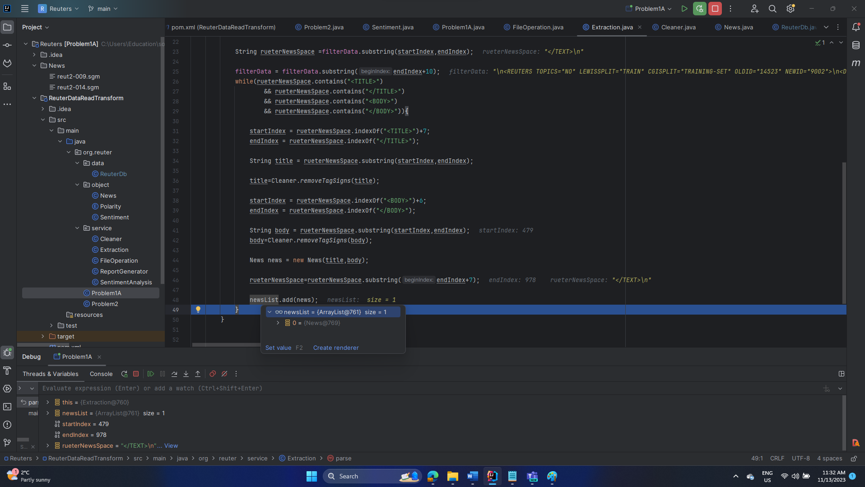

Figure 12: News object

There will be 1560 news objects

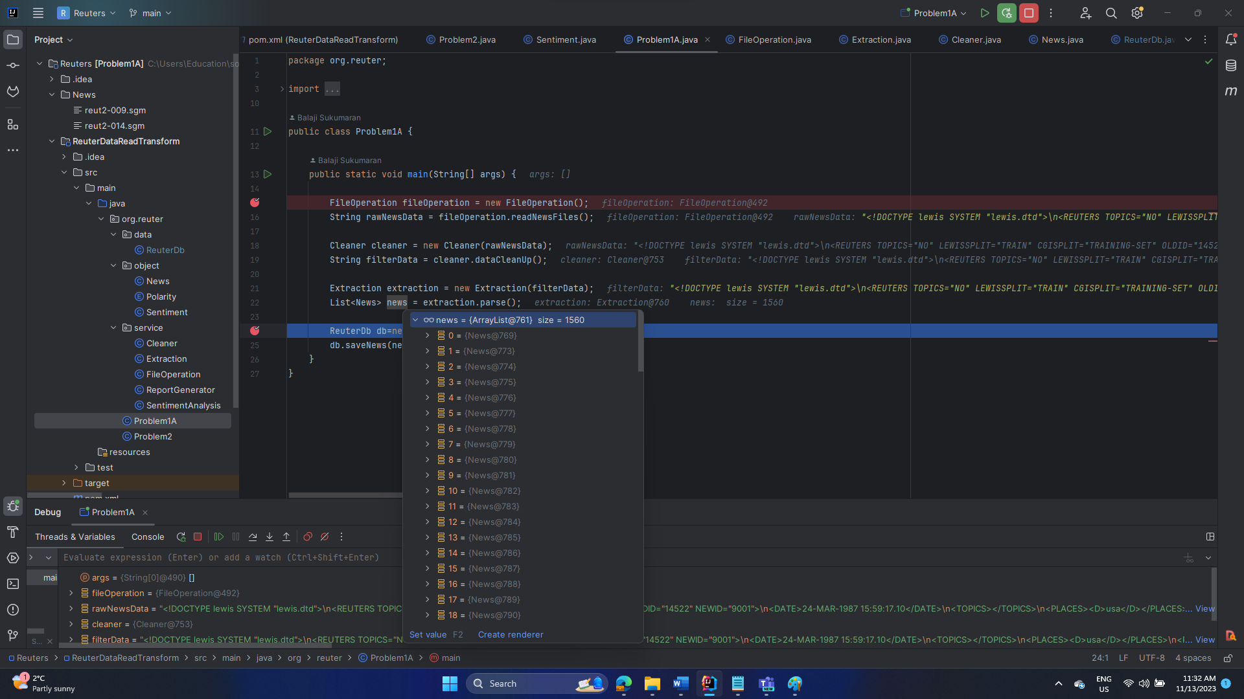

Figure 13: News list containing 1560 news objects

Insert all the news object into MongoDB. One by One.

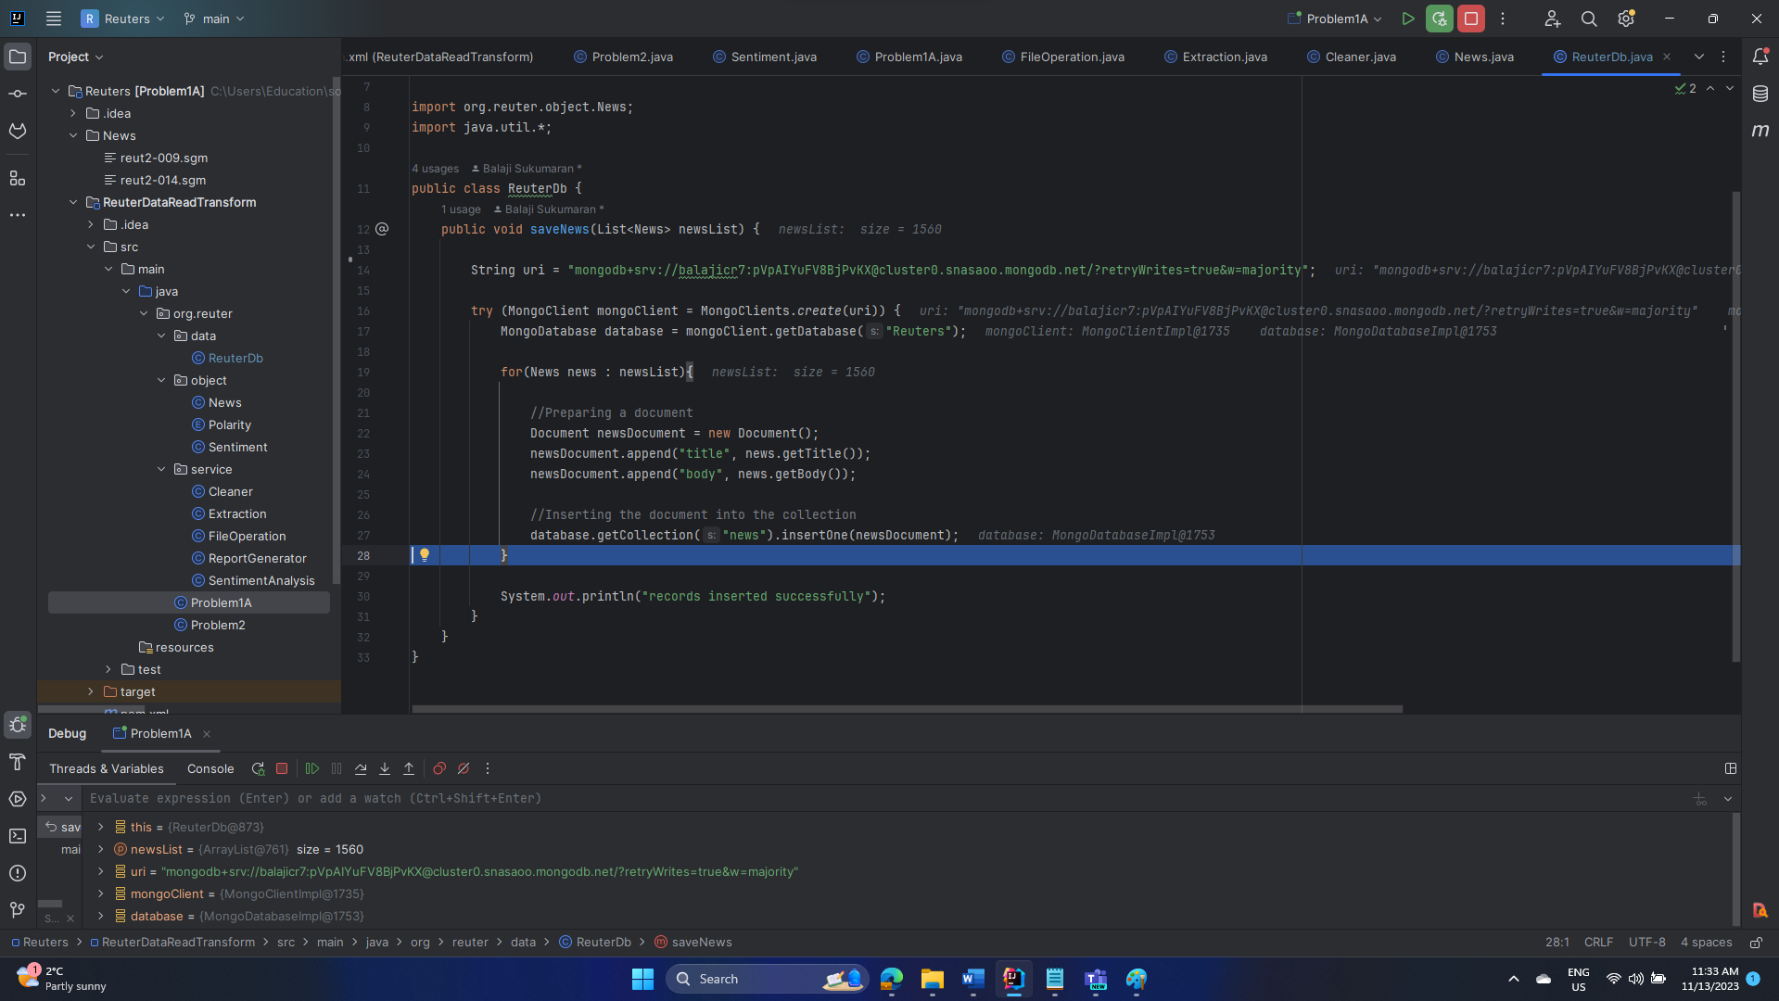

Figure 14: MongoDB insertion logic

All the cleaned news data inserted into the Mongo DB successfully.

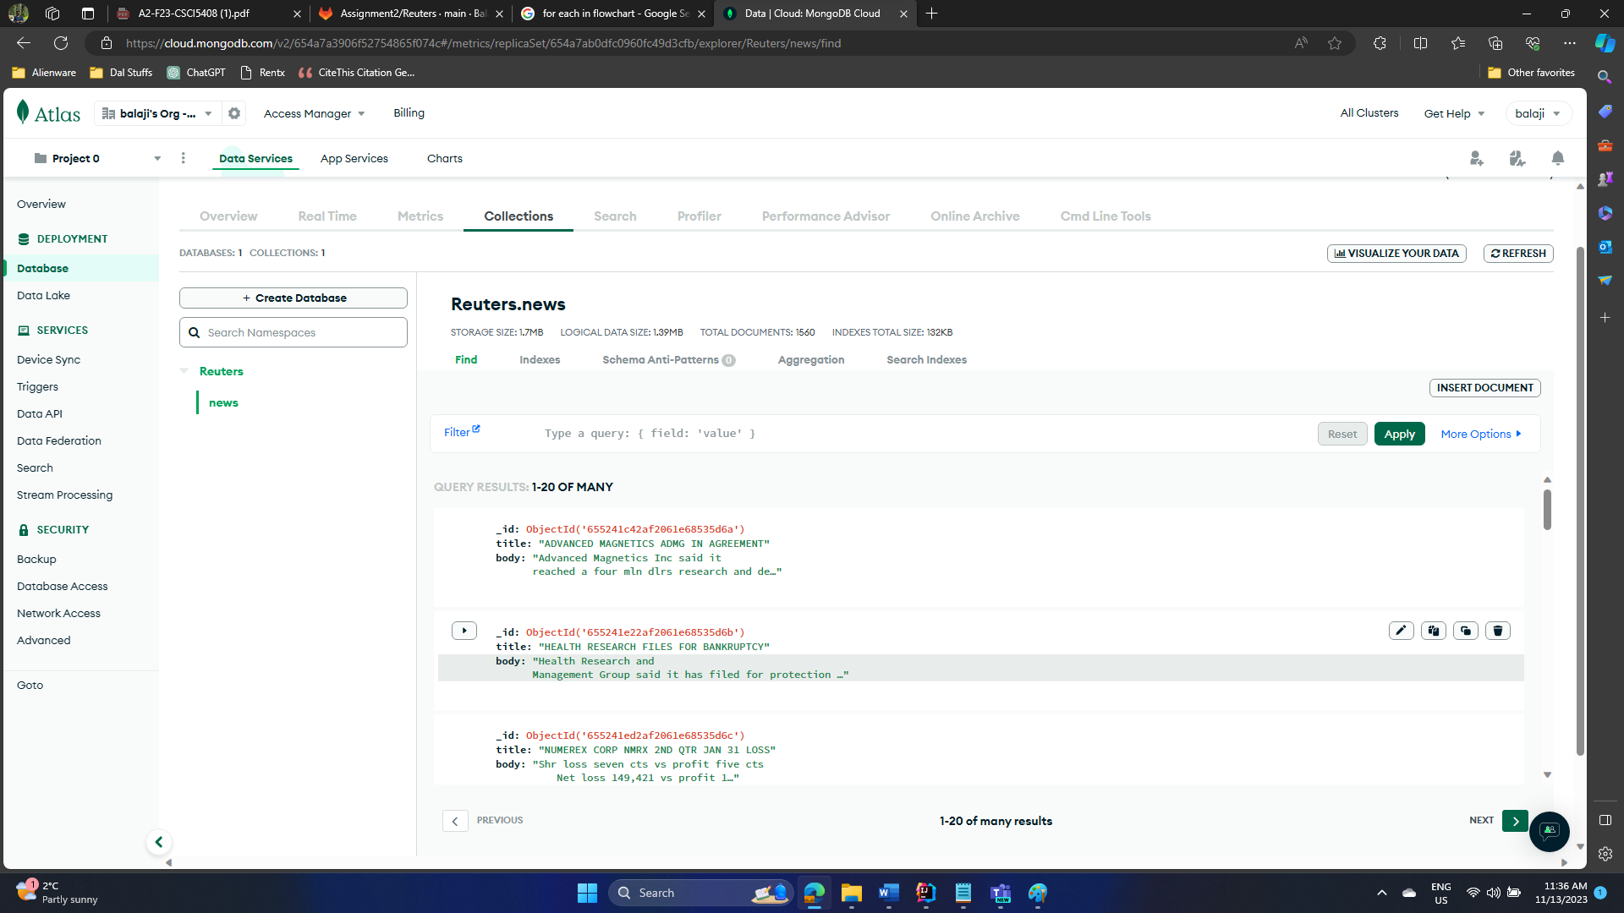

Figure 15: MongoDB with news Content

**Problem Statement 1B: Explanation of Problem 1B.**

I wrote a Java program to retrieve the contents of the news file 'reut2-009.sgm'. The program first removes all XML-like tags, as well as special characters, numbers, and HTML escape characters. This clean-up process is achieved using a regular expression in Java. Next, the program reads a file containing stop words and removes these stop words from the news content. Once the cleanup is complete, a Spark session object is created. This object is then used to establish a Spark context. Words are parallelized, and their occurrences are counted using 'mapToPair' and 'reduceByKey' methods [3]. After completing the frequency count, the program loops through each word's frequency to find the minimum and maximum frequencies.

To deploy this solution, a Spark cluster is set up in a GCP (Google Cloud Platform) account. The JAR file, stop words file, and the news file ('reut2-009.sgm') are uploaded to this cluster. Once uploaded, the JAR file is executed with the following command:

spark-submit --class org.reuter.Problem1B ./ReuterDataReadTransform-1.0-SNAPSHOT.jar

Here, the --class flag specifies the class to be executed.

**Problem Statement 1B: Test Cases and Evidence of Testing using screenshots.**

Step 1: Read the news file content and remove the tag elements and special characters and the HTML escape characters.

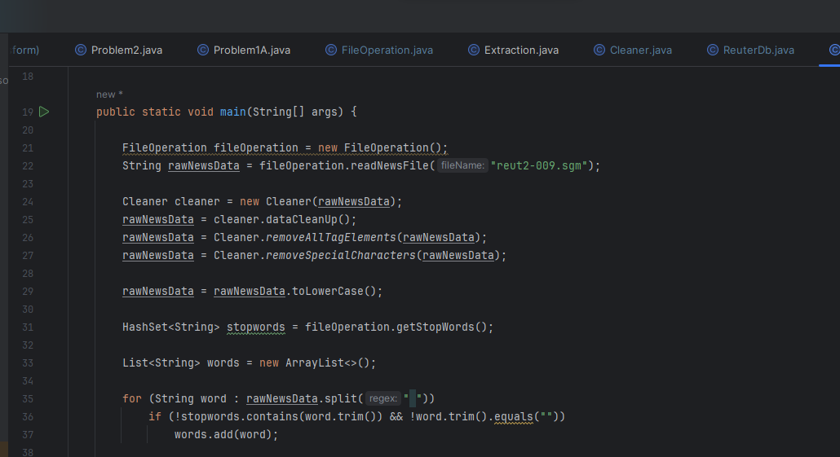

Figure 16: Problem 1B Main method

Following is the logics used for data clean-up.

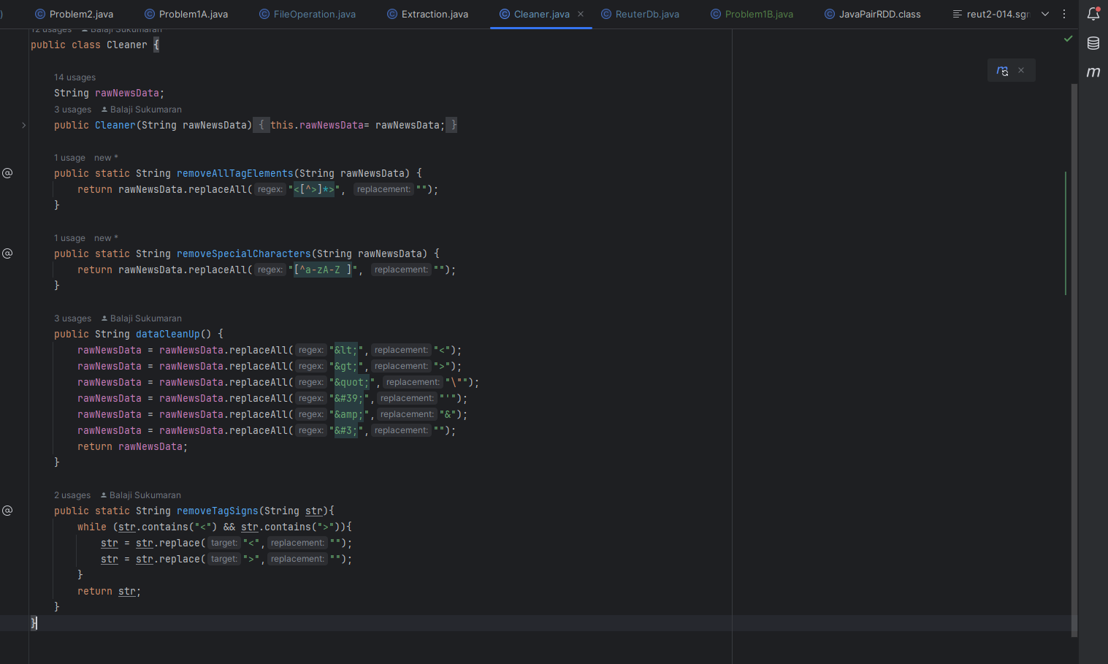

Figure 17: data clean up method

Step 2: Fed the cleaned words to spark context and found the frequency counts of each word in the data stream.

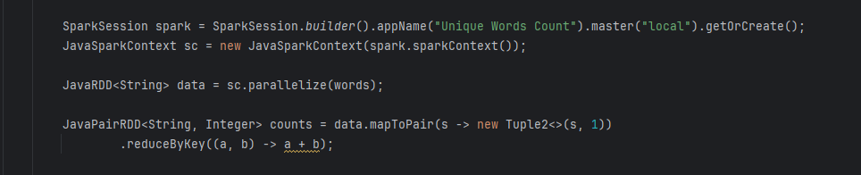

Figure 18: Spark related code to find the word frequency

Step 3: Loop through each word frequency and find the min and max frequencies and console out the same.

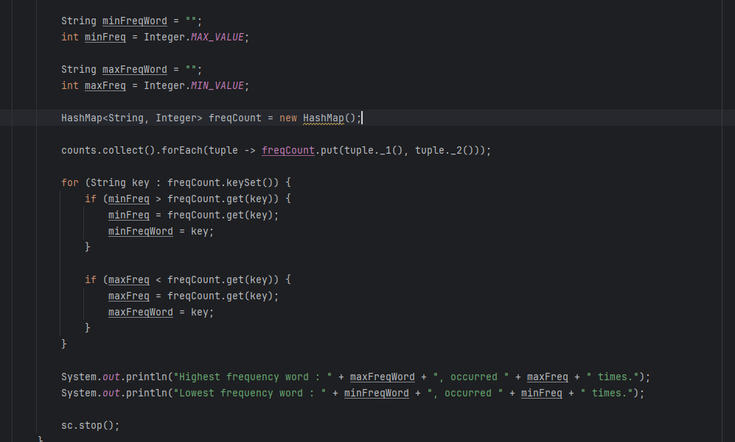

Figure 19: Min and Max frequency of words

Step 4: Package the code (create the JAR file).

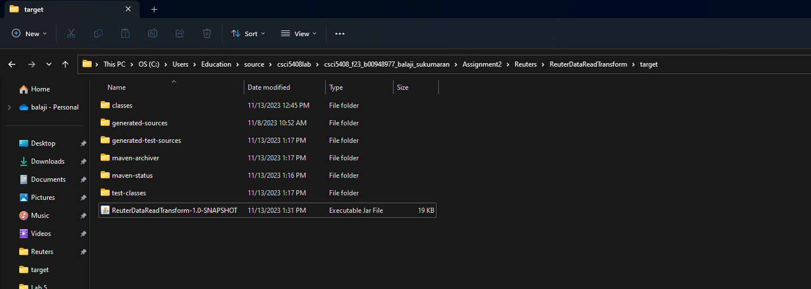

Figure 20: JAR file for the spark program

Step 5: Create a spark cluster in GCP.

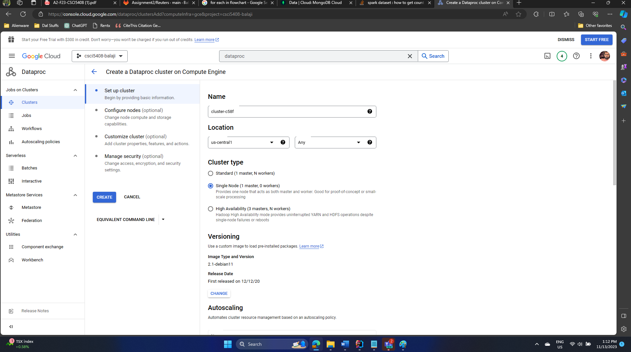

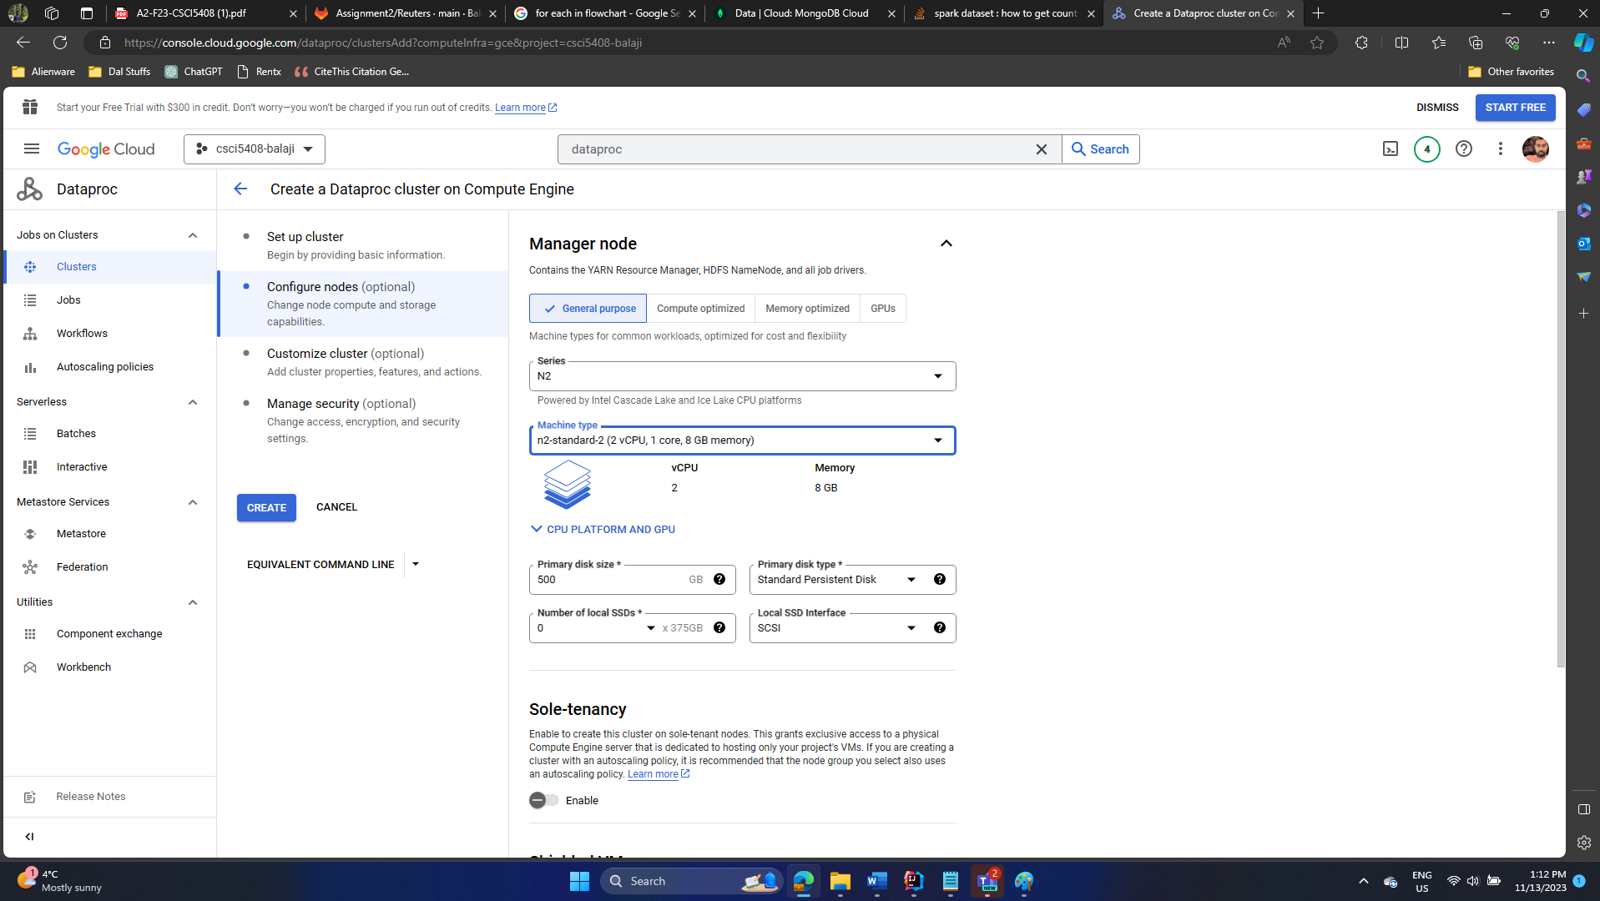

Figure 21: GCP spark cluster

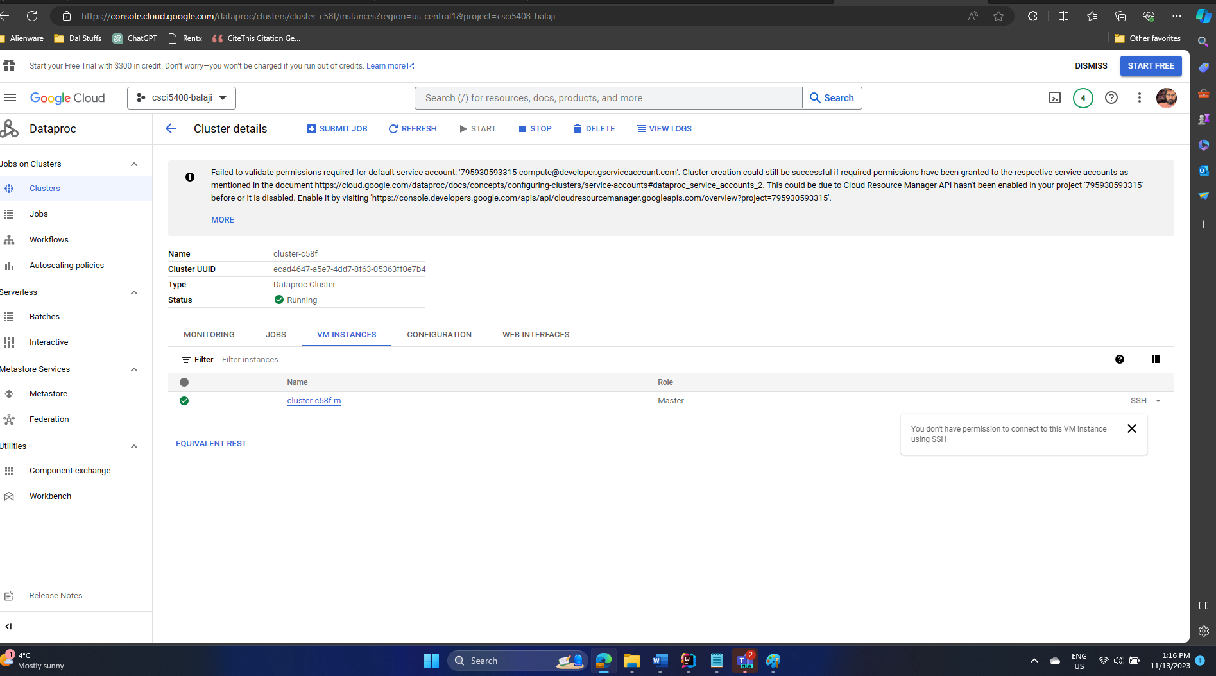

Figure 22: Spark cluster is created and running

Step 6: upload the jar files to spark cluster.

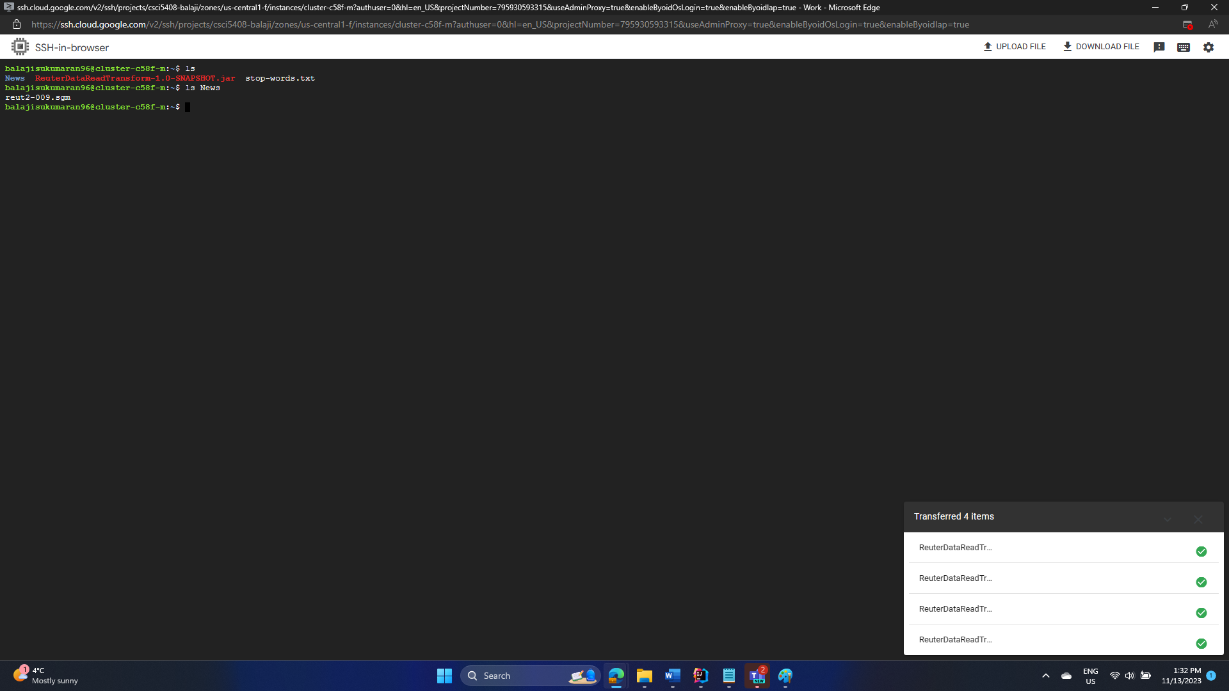

Figure 23: File upload successful

Step 7: Spark submit the program.

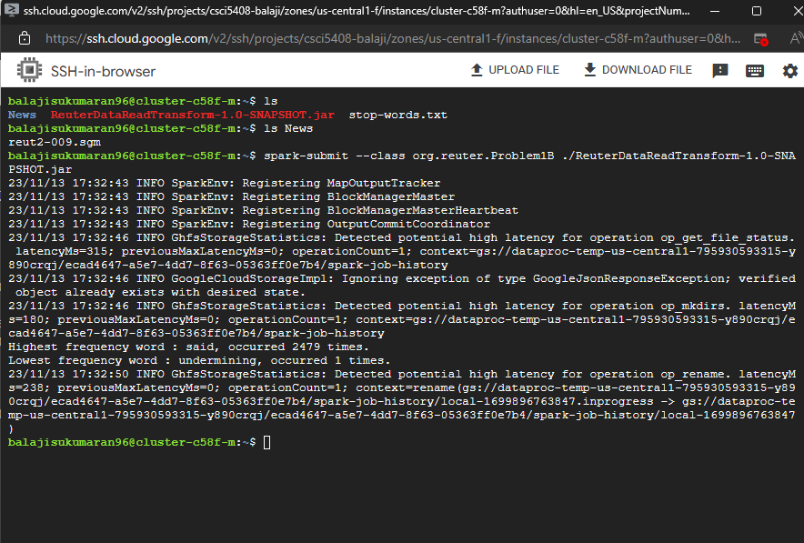

Figure 24: Spark output

**As displayed in the output,**

“said” occurred **maximum** number of times 2479

“undermining” occurred **minimum** number of times 1.

**Problem Statement 2: Test Cases and Evidence of Testing using screenshots.**

Step 1: Read the positive and negative words from the text files.

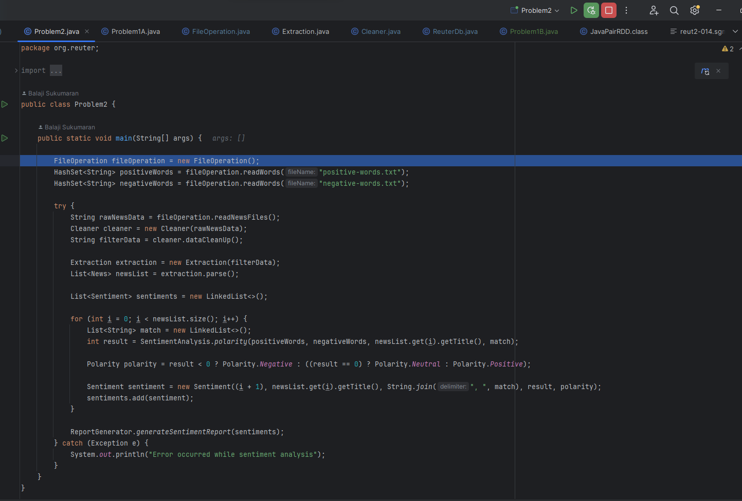

Figure 25: main method

Following is the logic to read the words. First read the positive-words.txt

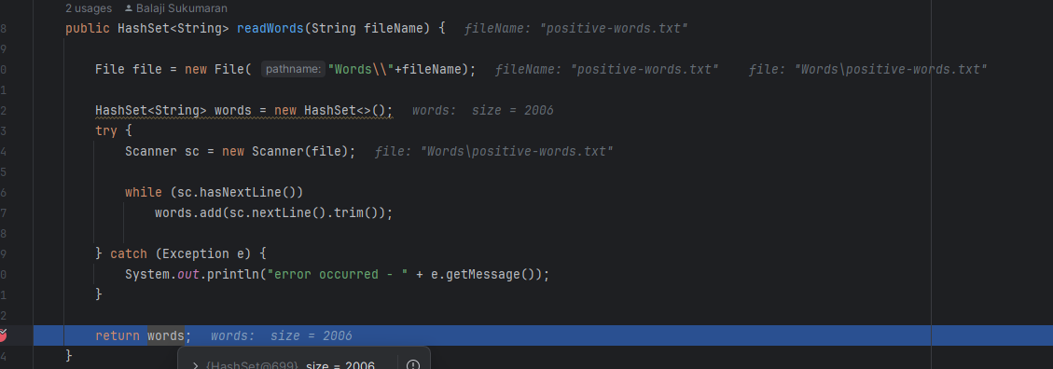

Figure 26: word file read

Read the negative words file (negative-words.txt)

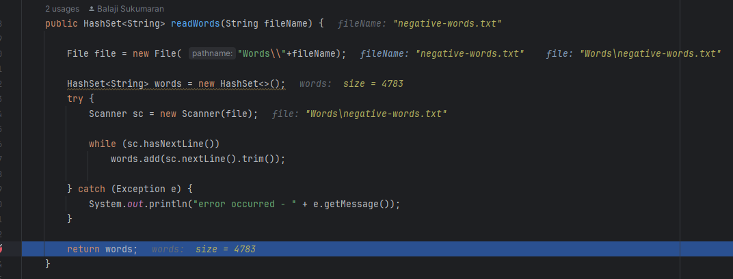

Figure 27: read negative words

Step 2: read the news files.

Go to the news file directory and read all the files and store it in a string.

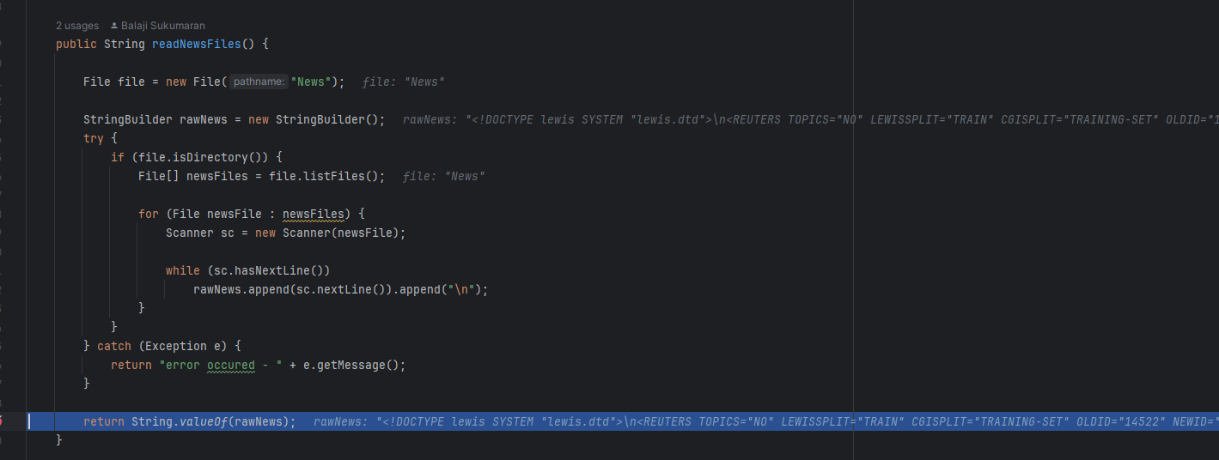

Figure 28: read news files

Step 3: Perform data clean-up.

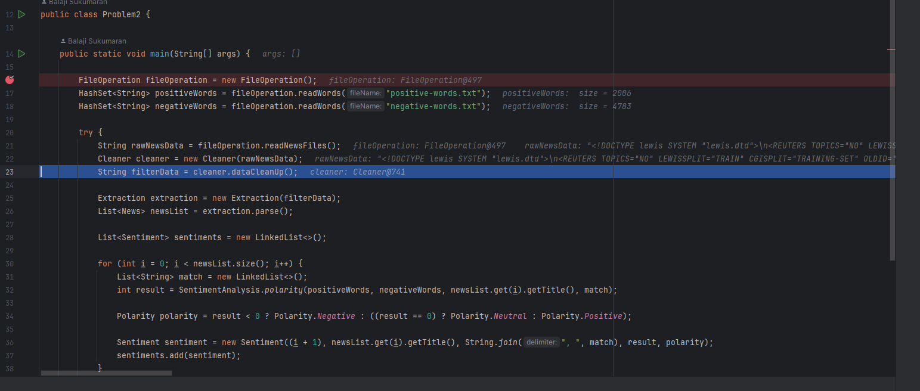

Figure 29: main method

Remove all the HTML escape characters and replace with appropriate ones.

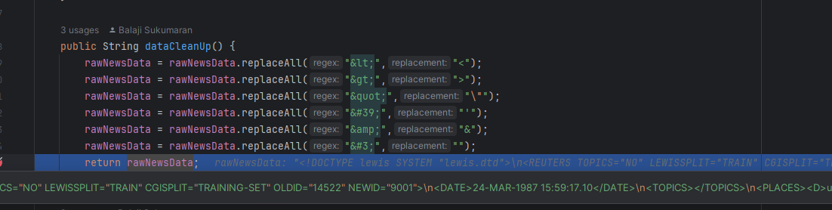

Figure 30: data cleanup

Step 4: Extract and parse the news file to create the news object.

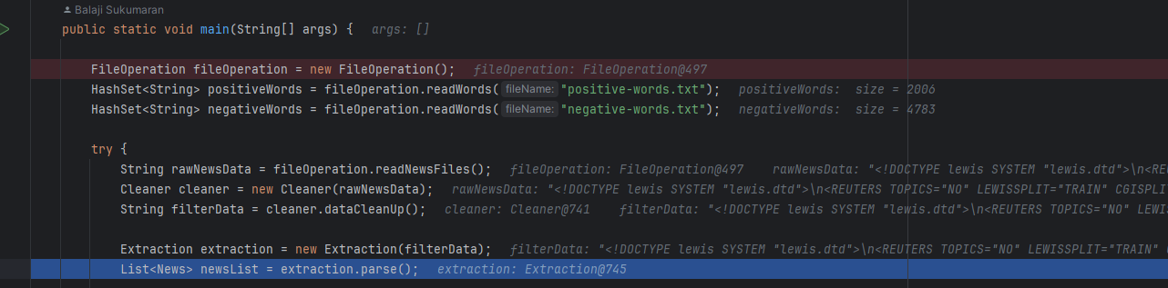

Figure 31: main method

Go to the each of the reuters tag and extract the tile and body contents and once it is created remove the special characters from title and body. Use this to create the news object. There are a total of 1560 words created

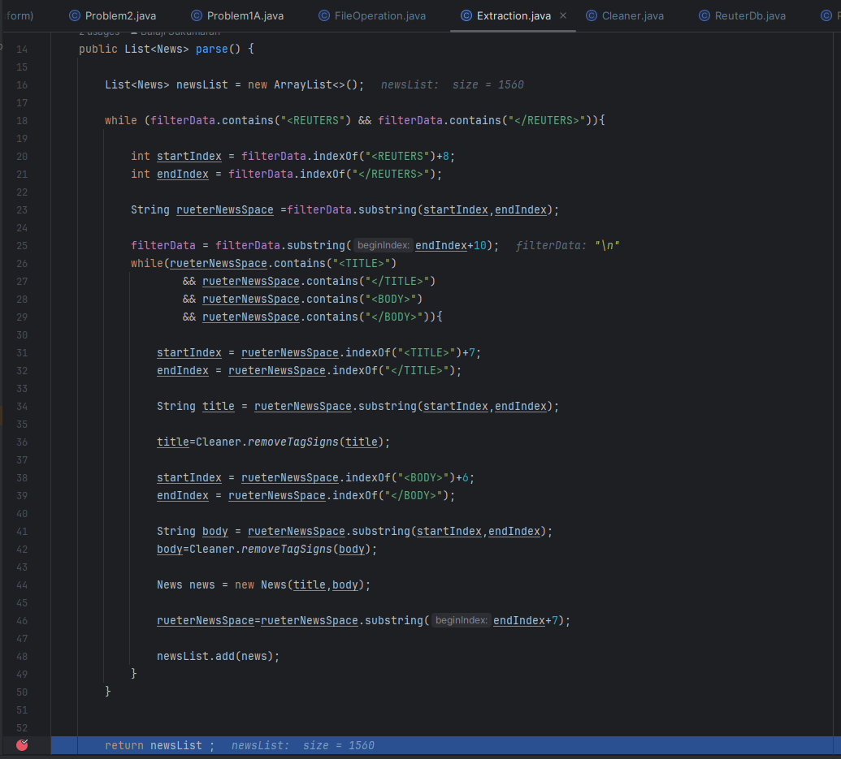

Figure 32: parsing logic for news file

Step 5: Transform and create the sentiment object using the news object.

* Determine the polarity and matched words of the given news title

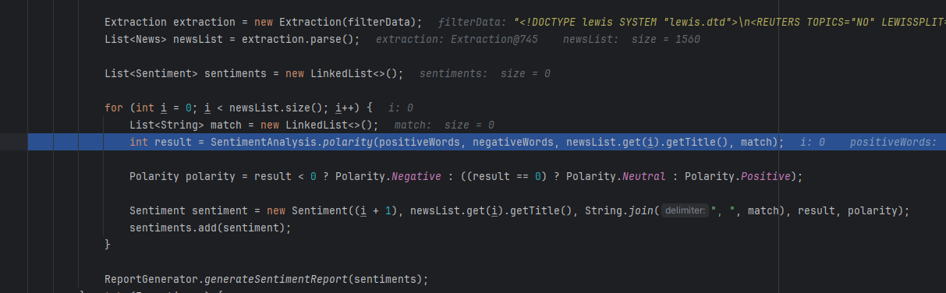

Figure 33: main method

* Logic to determine polarity: Go through each words in title and compare against the positive and negative word sets and increase the count by 1 for positive and reduce by 1 for negative.

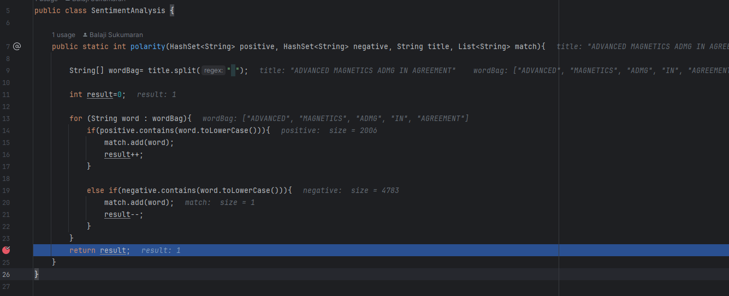

* Determine the polarity side by using the number generated

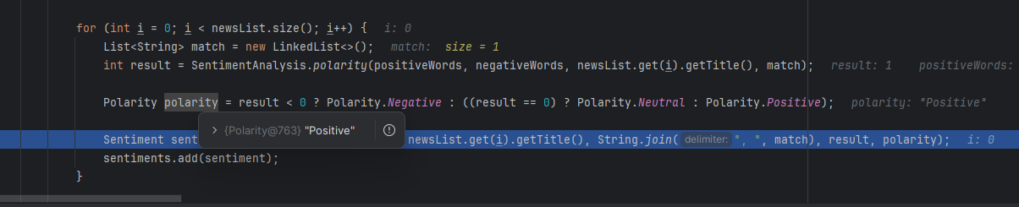

* Once we got the matched words and polarity use that to create the sentiment object.

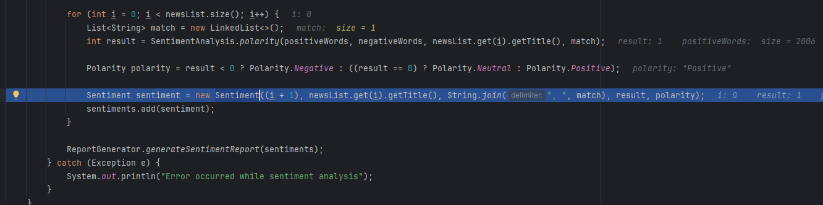

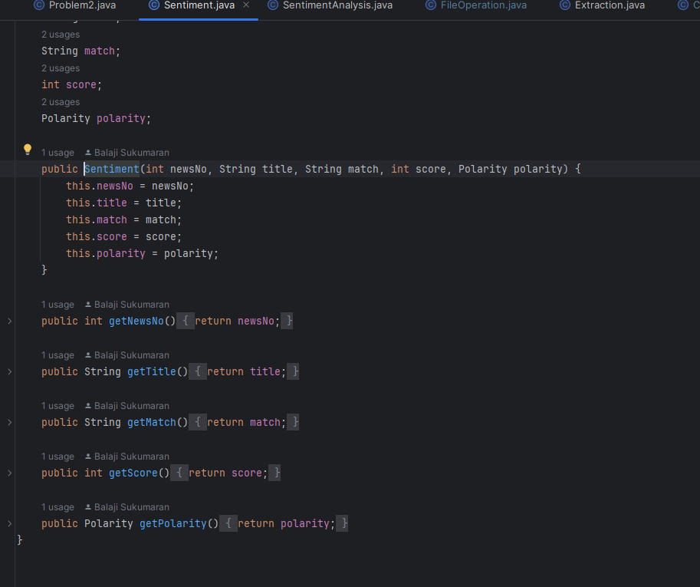

Figure 34: Sentiment class

Step 6: There are a total of 1560 sentiment objects for 1560 news objects. Convert it into a report

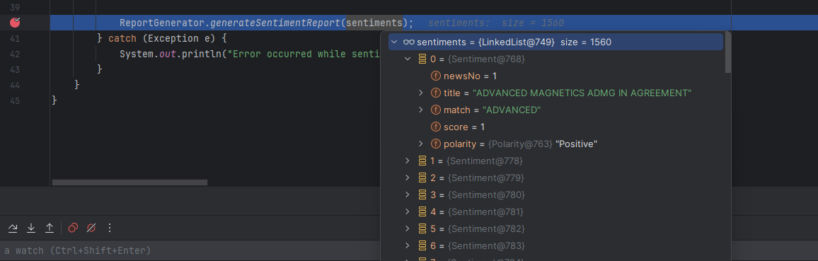

Figure 35: main method

Step 7: Create a HTML report for the 1560 sentiment objects

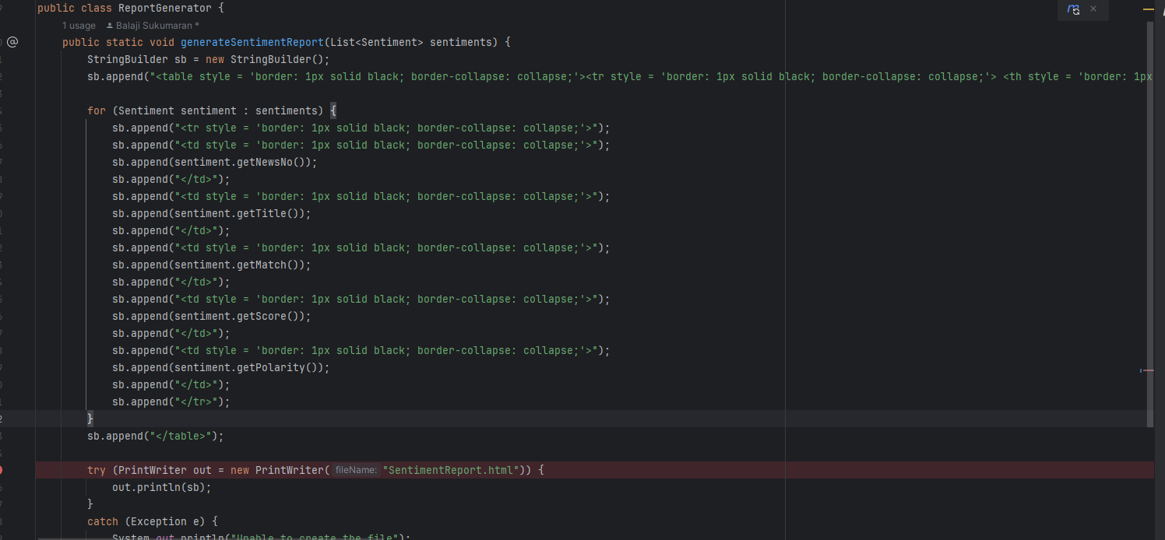

Figure 36: HTML report generator

Following are the report generated by the system.

Figure 37: HTML sentiment analysis report

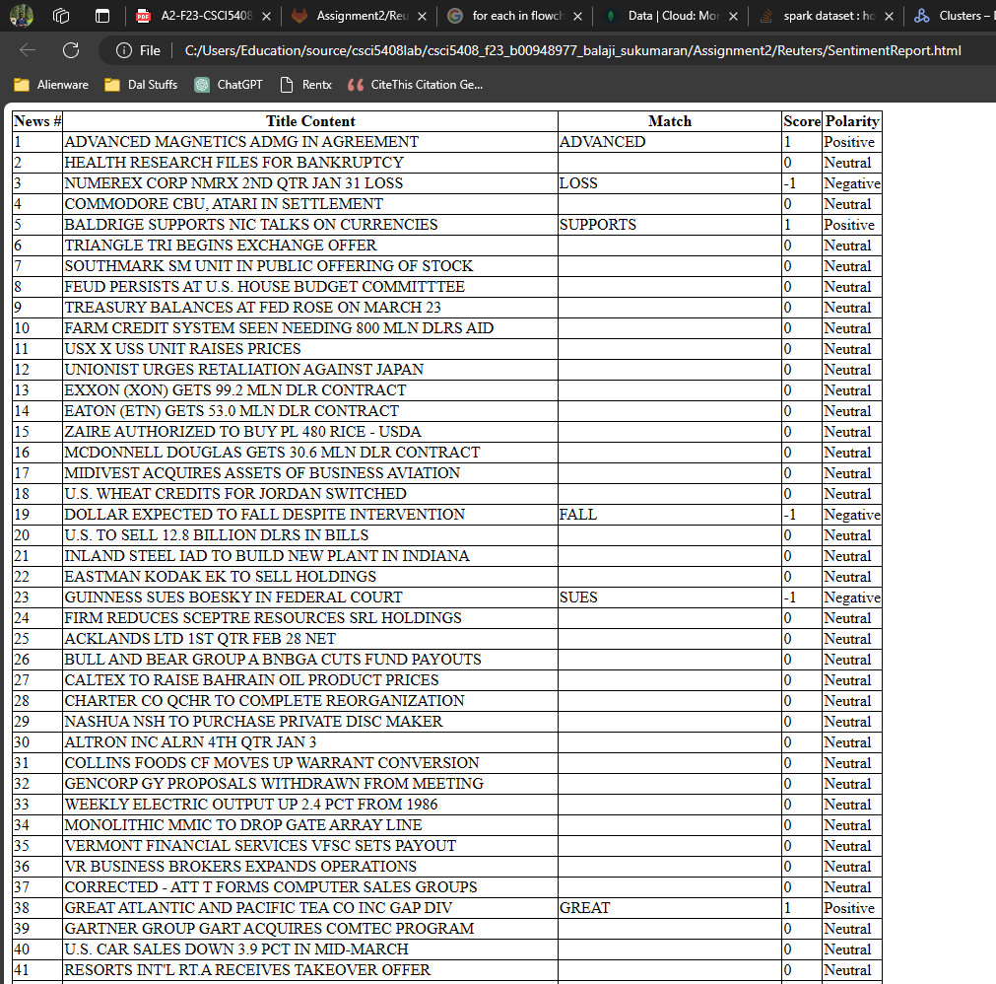

Figure 38: HTML sentiment analysis report

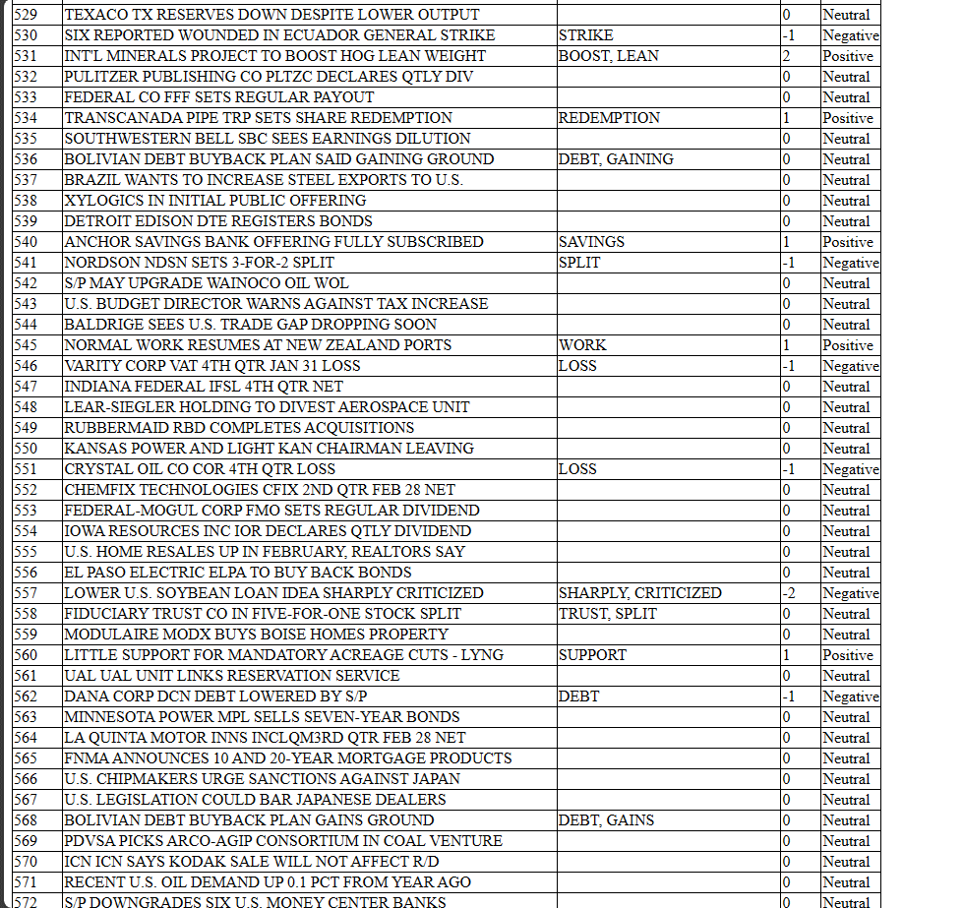

**REFERENCES:**

[1] “Why Use MongoDB and When to Use It?,” *MongoDB*. [Online]. Available: [Why Use MongoDB And When To Use It? | MongoDB](https://www.mongodb.com/why-use-mongodb). [Accessed: Nov 16, 2023].

[2] M. Krishna, “How to insert a document into a MongoDB collection using Java?,” *tutorialspoint,* 10th Apr, 2020*.* [Online]. Available: [How to insert a document into a MongoDB collection using Java? (tutorialspoint.com)](https://www.tutorialspoint.com/how-to-insert-a-document-into-a-mongodb-collection-using-java). [Accessed: Nov 16, 2023]

[3] “How to usemapToPairmethodinorg.apache.spark.api.java.JavaRDD,” *tabnine.* [Online]. Available: [org.apache.spark.api.java.JavaRDD.mapToPair java code examples | Tabnine](https://www.tabnine.com/code/java/methods/org.apache.spark.api.java.JavaRDD/mapToPair). [Accessed: Nov 16, 2023]